SOWIT Video Series – “A Stitch in Time Saves Nine”
(Video link: www.edb.gov.hk/sowit_stitch)

Lesson Plan
Suggested Levels
Upper Primary/Junior Secondary
Summary of the Learning Task
Students watch the SOWIT video “A Stitch in Time Saves Nine”, which is about two brother pigs whose houses were attacked by a wolf one night, their reactions to the challenging situation and the final results. Students are then guided to understand the meaning of the saying “A stitch in time saves nine”, learn about the related positive values and attitudes (e.g. be proactive, be positive, cherish what we have), give advice to the little pig, and design a poster to promote the message of being proactive.
Learning Objectives
Content
- To understand the meaning of the saying “A stitch in time saves nine.” through a story presented in the context of a video

Language
- To explore the story elements of the video (e.g. characters, setting, problem, solution)
- To show determination and the importance of being proactive using the sentence pattern “I need to/have to …”

Values and Attitudes
- To cultivate positive values and attitudes (e.g. be proactive, be positive, cherish what we have)
Sharing Learning Intentions
1. Introduce the objectives of the learning activities.
Pre-viewing
Part A: Making Predictions about the Theme of the Video
1. Refer students to Activity Sheet: Part A.
2. Draw students’ attention to the picture below. Guide students to make predictions about the theme of the video, and the consequences of different decisions.
Oh! There’s a small tear in my cardigan!
3. Discuss with students their ideas.
Viewing
Part B: Understanding the Story Elements
1. Refer students to Activity Sheet: Part B.
2. Introduce the story elements (i.e. characters, setting, problem, solution) before playing the video and instruct students to note down some key points for each element while watching the video.
3. Play the video “A Stitch in Time Saves Nine”.
4. Discuss with students the story elements of the video.
Post-viewing
Part C: Comparison of Characters
1. Refer students to Activity Sheet: Part C.
2. Guide students to compare the elder pig and the little pig in the following aspects:
- their personalities
- their time management
- their attitude towards work
3. Play the video again whenever necessary.
4. Discuss with students the attributes and elements that are the key to success, for example:
- determination/passion/courage/proactiveness
- ability to work under pressure
- willingness to reflect and learn from others
Part D: Understanding the Saying of Wisdom
1. Refer students to Activity Sheet: Part D.
2. Revisit the meaning of the saying “A stitch in time saves nine.” with students (i.e. solving a problem sooner rather than later will save you a lot of trouble).
3. Invite students to brainstorm some advice for the little pig using the sentence pattern “The little pig needs to/has to …”.
4. Ask students to design a poster to promote the message of being proactive. Think of an attractive title and use eye-catching images to draw readers’ attention.

SOWIT Video Series – “A Stitch in Time Saves Nine”
Activity Sheets
(Pre-viewing)
Part A: Making Predictions about the Theme of the Video
- What is the theme of the video? Write your prediction on the lines provided and share it with your classmates.
Oh! There’s a small tear in my cardigan!
The theme of the video is about _____________________________________________
_______________________________________________________________________
- If you were the girl, what would you do to the small tear in your cardigan? Write your thoughts in the boxes below.

- What will happen if I ignore the small tear in my cardigan? | - What will happen if I fix the small tear in my cardigan?

(Viewing)
Part B: Understanding the Story Elements
- Watch the video and complete the storyline below.
- Who were the characters?
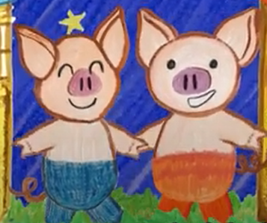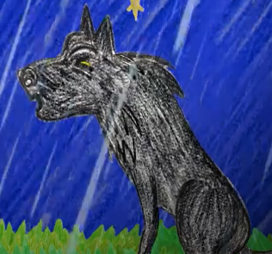
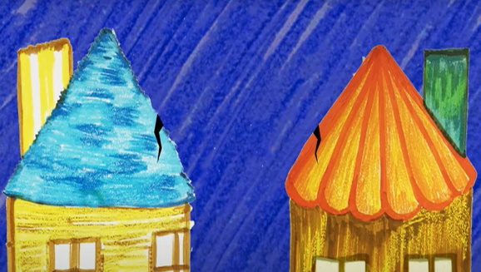
- When and where did the story take place?
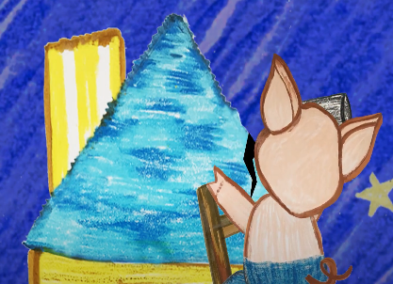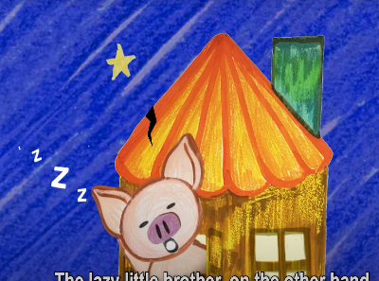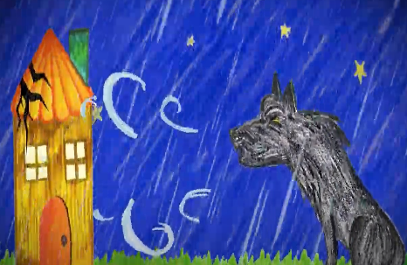
(c) What problem did the two brother pigs face?

- How was the problem solved? What happened in the end?

(Post-viewing)
Part C: Comparison of Characters
- Compare the personal attributes of the elder pig and the little pig:
 | Personality | Time management | Attitude towards work
the little pig | (a) | (b) | (c)
the elder pig | (d) | (e) | (f)

- Which character do you like better? Why?
______________________________________________________________________________________________________________________________________________

- What other attributes and elements are the key to success?
_______________________________________________________________________
_______________________________________________________________________

Part D: Understanding the Saying of Wisdom
- What is the message conveyed by the story?
_________________________________________________________________
_________________________________________________________________
- What is the meaning of the saying “A stitch in time saves nine”?
_________________________________________________________________
_________________________________________________________________
- What advice would you give to the little pig? Use the sentence pattern “The little pig needs to …/has to …” to give him some suggestions for improvement.

A stitch in time saves nine

- Design an A4 poster to promote the message of being proactive. Think of an attractive title and use eye-catching images to draw readers’ attention. Please use an A4 sheet of paper for your poster.

SOWIT Video Series – “A Stitch in Time Saves Nine”
Activity Sheets (Suggested Answers)
Part A: Making Predictions about the Theme of the Video
- The theme of the video is about fixing a tear/problem as soon as possible. (Accept any reasonable answers.)
2(a) Accept any reasonable answers.
2(b) Accept any reasonable answers.

Part B: Understanding the Story Elements
1(a) The characters were the elder pig, the little pig and the wolf.
1(b) The story took place in two houses on a stormy night.
1(c) A small crack developed in the two houses where they lived in. A wolf came one night and blew at the houses in order to catch the two brothers. (Accept any reasonable answers.)
1(d) When the crack on the roof of his house was still small, the elder pig fixed it. The little pig did not fix the crack but went to sleep. The crack got bigger and bigger. The little pig’s house collapsed when the wolf blew at it. The little pig cried for help and ran into his elder brother’s house. The wolf was unable to blow the house down. It could not catch the two brothers and left in the end. (Accept any reasonable answers.)

Part C: Comparison of Characters
1(a) The little pig was lazy and did not want to deal with problems. (Accept any reasonable answers.)
1(b) The little pig did not make good use of his time to fix the crack before it became big. He just ignored the problem. (Accept any reasonable answers.)
1(c) The little pig was indolent/irresponsible. (Accept any reasonable answers.)
1(d) The elder pig was self-disciplined/careful. (Accept any reasonable answers.)
1(e) The elder pig made good use of his time to fix the crack before it became big. He acted immediately after he noticed the problem. (Accept any reasonable answers.)
1(f) The elder pig was proactive/careful. (Accept any reasonable answers.)
- Accept any reasonable answers.
- Determination/passion/courage/proactiveness are some key attributes and elements. (Accept any reasonable answers.)
Part D: Understanding the Saying of Wisdom
- It is better to act or deal with problems immediately. If we wait until later, the problems will get worse and take longer to settle.
- Solving a problem sooner rather than later will save us a lot of trouble.
- Accept any reasonable answers.
- Accept poster design with reasonable and creative ideas/images/design that help to promote the message of being proactive.

